**ASSIGNMENT**

**Bootstrap**

**Que1.** What are the advantages of Bootstrap?

**Ans.**

* Bootstrap’s ready-made components accelerate development, enabling faster project completion.
* The built-in grid system ensures websites adapt seamlessly to diverse screen sizes and devices.
* Bootstrap maintains a uniform look and feel across various elements, ensuring a cohesive user experience.
* Bootstrap handles browser differences, minimizing the need for extensive testing and ensuring a consistent user experience.
* Customizable themes, variables, and mix provide flexibility to match specific project requirements and branding.
* Being open-source, Bootstrap benefits from a robust community, offering resources, documentation, and third-party plugins.

**Que2.** What is a Bootstrap Container, and how does it work?**Ans.** Bootstrap Containers are the most basic layout element in Bootstrap. Bootstrap Containers are very essential and basic building blocks of bootstrap that wrap a page’s content. It’s responsible for setting and aligning content within it according to viewport or given device. Containers are defined within the container class (.container). In other words, we can say that containers are established the width for the layout to give the content. Elements and content are added within the container.

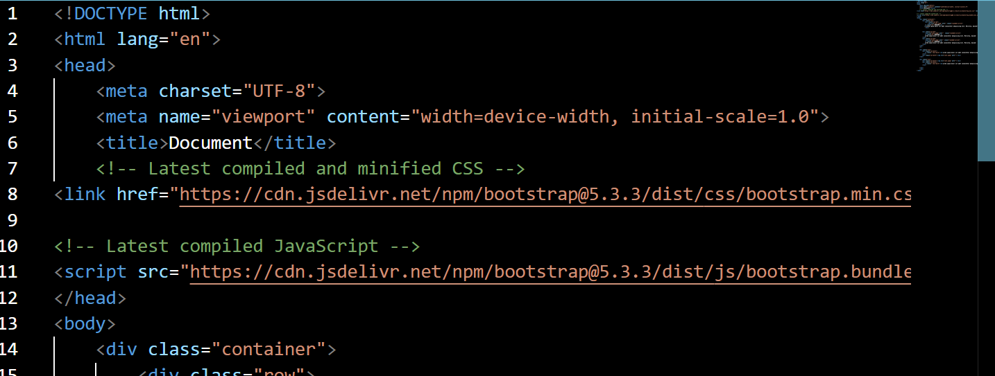

**Que3.** What are the default Bootstrap text settings?

**Ans.** Bootstrap's global default font-size is 14px, with a line-height of 1.428.

This is applied to the <body> element and all paragraphs (<p>).

In addition, all <p> elements have a bottom margin that equals half their computed line-height (10px by default).

Default Bootstrap are:

* <h1>-<h6>
* <mark>
* <small>
* <abbr>
* <blockquote>
* <dl>
* <code>

**Que4.** What do you know about the Bootstrap Grid System?

**Ans.** Bootstrap Grid System allows up to 12 columns across the page. You can use each of them individually or merge them together for wider columns. You can use all combinations of values summing up to 12. You can use 12 columns each of width 1, or use 4 columns each of width 3 or any other combination.

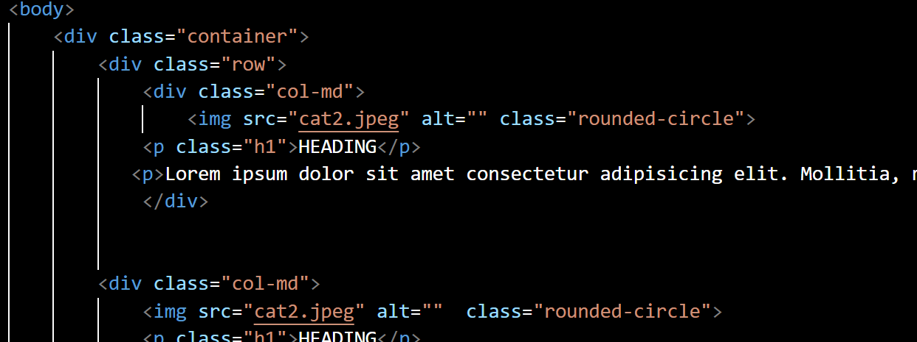

**Que5.** What is the difference between Bootstrap 4 and Bootstrap 5?

**Ans.**

|  |  |
| --- | --- |
| Bootstrap 4 | Bootstrap 5 |
| * It has 5 tier (xs, sm, md, lg, xl). | * It has 6 tier (xs, sm, md, lg, xl, xxl). |
| * It has limited colors. | * Extra colors added with the looks, A card improved color palette. |
| * It has jquery and all related plugins. | * Jquery is removed and switched to vanilla JS with some working plugins. |
| * Bootstrap 4 supports both IE 10 and 11. | * Bootstrap 5 doesn’t support IE 10 and 11. |
| * We cannot modify utilities in bootstrap 4. | * Bootstrap 5 gave freedom to modify and also create our own utility. |
| * Columns can be positioned relative. | * Columns cannot be positioned relative. |

**Que6.** What is a Button Group, and what is the class for a basic Button Group?**Ans.** Bootstrap button group puts multiple buttons together on a single line, horizontally or vertically.

Group a series of buttons together on a single line or stack them in a vertical column.

**Que7.** How can you use Bootstrap to make thumbnails?**Ans.** A thumbnail is a small image that represents a larger image. Bootstrap has an easy way to do this with thumbnails. Bootstrap’s .thumbnail class is used to show linked images in grids (grid system), a thumbnail is created using class .thumbnail within the element <a>. The class .col-sm-* and .col-md-* (where * represent number ), it is used to create grids of the images.

**Que8.** In Bootstrap 4, what is flexbox?

**Ans.** Flexbox is a one-dimensional layout system that we can use to create a row or a column axis layout. It makes our life easier to design and build responsive web pages without having to use tricky hacks and a lot of float and position properties in our CSS code.

**Que9.** How can one create an alert in Bootstrap?**Ans.** alert-secondary, . alert-light, and . alert-dark are been used to represent the alert message with different behavior. We will generate the dynamic alert message when the user clicks on the button.

**Que10.** What is a bootstrap card and how would you create one?

**Ans.**

